**Objective:-** Design a dynamic table based on user input (rows and columns). in each cell add a text field to take input. On the submit button no text field should be empty.

**HTML Code :-**

<!DOCTYPE html>

<html lang="en">

<head>

<meta charset="UTF-8">

<meta name="viewport" content="width=device-width, initial-scale=1.0">

<title>Assigment-3</title>

<link href="https://maxcdn.bootstrapcdn.com/bootstrap/4.5.2/css/bootstrap.min.css" rel="stylesheet">

<link rel="stylesheet" href="./style.css">

</head>

<body>

<div class="container mt-5">

<div id="question_add">

<input type="text" class="form-control mb-2" name="txtQuestion" id="txtQuestion"

placeholder="Enter The Question">

<input type="text" class="form-control mb-2" name="txtOpt1" id="txtOpt1" placeholder="Enter The Option-1">

<input type="text" class="form-control mb-2" name="txtOpt2" id="txtOpt2" placeholder="Enter The Option-2">

<input type="text" class="form-control mb-2" name="txtOpt3" id="txtOpt3" placeholder="Enter The Option-3">

<input type="text" class="form-control mb-2" name="txtOpt4" id="txtOpt4" placeholder="Enter The Option-4">

<b>Select The Correct Answer :- </b>

<select class="form-control mb-2" name="corrAns" id="corrAns">

<option value="1">Option-1</option>

<option value="2">Option-2</option>

<option value="3">Option-3</option>

<option value="4">Option-4</option>

</select>

<button type="button" class="btn btn-primary mb-2" id="addQue" onclick="addQuestion()">Add</button>

</div>

<div class="question" id="labelQuestion">

Question text

</div>

<div class="answer mt-3" id="answer">

</div>

<div class="navigation mt-3">

<button type="button" class="btn btn-secondary" id="btnPrev" onclick="onClickPrev()">Prev</button>

<button type="button" class="btn btn-primary ml-2" id="btnCheck" onclick="checkAnswer()">Check

Answer</button>

<button type="button" class="btn btn-secondary ml-2" id="btnNext" onclick="onClickNext()">Next</button>

<button type="button" class="btn btn-primary ml-2" id="btnCheckResult" onclick="onClickResult()"

style="display:none">Check Result</button>

</div>

<div id="displayresult"></div>

</div>

<script src="https://maxcdn.bootstrapcdn.com/bootstrap/4.5.2/js/bootstrap.min.js"></script>

<script src="myjs.js"></script>

</body>

</html>

**CSS Code :-**

body {

font-family: 'Segoe UI', Tahoma, Geneva, Verdana, sans-serif;

background-color: #f8f9fa;

margin: 0;

padding: 0;

}

.container {

max-width: 600px;

margin: 0 auto;

padding: 20px;

background-color: #fff;

border-radius: 10px;

box-shadow: 0 0 10px rgba(0, 0, 0, 0.1);

}

.question,

.answer {

background-color: #e9ecef;

padding: 15px;

margin-top: 20px;

border-radius: 5px;

}

.navigation {

text-align: center;

margin-top: 20px;

}

#question_add {

margin-bottom: 20px;

background-color: #fff;

padding: 20px;

border-radius: 10px;

box-shadow: 0 0 20px rgba(0, 0, 0, 0.1);

}

#question_add input[type="text"],

#question_add select {

width: calc(100% - 20px);

padding: 10px;

margin-bottom: 10px;

box-sizing: border-box;

border: 1px solid #ccc;

border-radius: 5px;

}

#question_add input[type="text"]:focus,

#question_add select:focus {

outline: none;

border-color: #007bff;

}

#question_add input[type="button"] {

padding: 10px 20px;

background-color: #007bff;

color: #fff;

border: none;

border-radius: 5px;

cursor: pointer;

transition: background-color 0.3s;

}

#question_add input[type="button"]:hover {

background-color: #0056b3;

}

.question,

.answer {

background-color: #fff;

padding: 20px;

margin-bottom: 20px;

border-radius: 10px;

box-shadow: 0 0 20px rgba(0, 0, 0, 0.1);

}

.navigation {

text-align: center;

}

.navigation button {

padding: 10px 20px;

margin: 0 5px;

background-color: #007bff;

color: #fff;

border: none;

border-radius: 5px;

cursor: pointer;

transition: background-color 0.3s;

}

.navigation button:hover {

background-color: #0056b3;

}

#displayresult {

margin-top: 20px;

}

**Javascript Code :-**

var data = [

{

question: "This is first question",

answers: ["ans1 opt1", "ans1 opt2", "ans1 opt3", "ans1 opt4"],

correct_opt: 1,

},

{

question: "This is second question",

answers: ["ans2 opt1", "ans2 opt2", "ans2 opt3", "ans2 opt4"],

correct_opt: 2,

},

{

question: "This is third question",

answers: ["ans3 opt1", "ans3 opt2", "ans3 opt3", "ans3 opt4"],

correct_opt: 3,

},

{

question: "This is fourth question",

answers: ["ans4 opt1", "ans4 opt2", "ans4 opt3", "ans4 opt4"],

correct_opt: 4,

},

];

var currInd = 0;

var response = [];

displayQuiz();

function displayQuiz() {

document.getElementById("labelQuestion").innerText = data[currInd]["question"];

let optHtml = "";

data[currInd]["answers"].forEach((answer, index) => {

optHtml +=

' <div class="ans-opt" id="opt_' +

(index + 1) +

'">' +

'<input type="radio" name="options" value="' +

(index + 1) +

'"';

if (response[currInd] && response[currInd]["res"] == index + 1) {

optHtml += 'checked = "checked"';

}

optHtml += ">" +

answer +

"</div>";

});

document.getElementById("answer").innerHTML = optHtml;

if (currInd == 0) {

document.getElementById("btnPrev").style.display = "none";

} else {

document.getElementById("btnPrev").style.display = "inline";

}

if (currInd == data.length - 1) {

document.getElementById("btnNext").style.display = "none";

document.getElementById("btnCheckResult").style.display = "inline";

} else {

document.getElementById("btnNext").style.display = "inline";

document.getElementById("btnCheckResult").style.display = "none";

}

}

function onClickNext() {

checkAnswer();

currInd++;

displayQuiz();

}

function onClickPrev() {

currInd--;

displayQuiz();

}

function checkAnswer() {

var val = document.querySelector('input[type="radio"]:checked').value;

if (val == data[currInd]["correct_opt"]) {

response[currInd] = { res: val, istrue: true };

alert("Good work");

} else {

response[currInd] = { res: val, istrue: false };

alert("Oops you miss");

}

}

function onClickResult() {

checkAnswer();

var html = "";

response.forEach((resp, index) => {

html +=

"<p>Ques " +

(index + 1) +

": option selected :" +

resp.res +

" istrue: " +

resp.istrue +

" </p>";

});

document.getElementById("displayresult").innerHTML = html;

}

function addQuestion() {

let newquestion = document.getElementById('txtQuestion').value;

let option1 = document.getElementById('txtOpt1').value;

let option2 = document.getElementById('txtOpt2').value;

let option3 = document.getElementById('txtOpt3').value;

let option4 = document.getElementById('txtOpt4').value;

let correctopt = parseInt(document.getElementById('corrAns').value);

data.push ({ question: newquestion, answers: [option1, option2, option3, option4 ], correct_opt: correctopt });

}

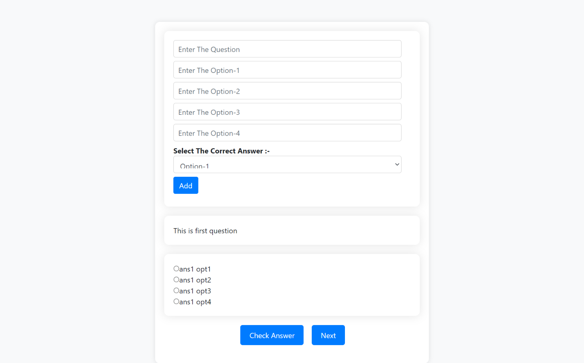**Output :-**